Dept. of CSE
CSE 4132
Assignment- 2

Problems

- A small object is launched into flight from the ground at a speed of 80 miles/hour at
45 degrees above the horizontal over level ground. Determine the time of flight and the distance traveled when the ball returns to the ground. Also plot the graph (Distance ~ Height). Use the following equations-

x(t) = vt cosø
y(t) = vt sinø – (1/2)gt²

- Compute SNR for the noisy signal Noisy signal. The signal model is
x= s+n, where s is the signal and n is the Gaussian noise.

SNR = 20 log₁₀ (ơ_{s}/ơ_{n}). Plot the signal too.

- Consider the discontinuous signal:
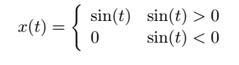
plots this signal over the range t = [0,50] s.

